NAME:S.DEVI SHREE
REGISTER NO:192511149
CSA0503-DATABASE MANAGEMENT SYSTEMS
LAB PRACTICAL
EXP NO:10 Database with VIEW and INDEX
AIM:
To create view and index on the given relation.
DESCRIPTION:
VIEW:
MySQL has supported database views since version 5+. In MySQL, almost features of views conform to the SQL:
2003 standard. MySQL processes query against the views in two ways:
1.In a first way, MySQL creates a temporary table based on the view definition
2. Statement and executes the incoming query on this temporary table.
3.In a second way, MySQL combines the incoming query with the query defined the view into one query and executes the combined query.
SYNTAX- VIEW:
CREATE [ALGORITHM = {MERGE | TEMPTABLE | UNDEFINED}]
VIEW [database_name].[view_name]
AS [SELECT statement]
INDEX:
A database index, or just index, helps speed up the retrieval of data from tables. When you query data from a table, first MySQL checks if the indexes exist, then MySQL usesthe indexesto select exact physical corresponding rows of the table instead of scanning the whole table..
SYNTAX- INDEX:
CREATE [UNIQUE|FULLTEXT|SPATIAL] INDEXindex_name
USING [BTREE | HASH | RTREE]
ON table_name (column_name [(length)] [ASC | DESC],...)

Questions on View:
1. Create a view with name ‘v1’ using employees1 table which holds the value of employee_id and salary of employee.
2. Do the insert and delete records from v1 table.
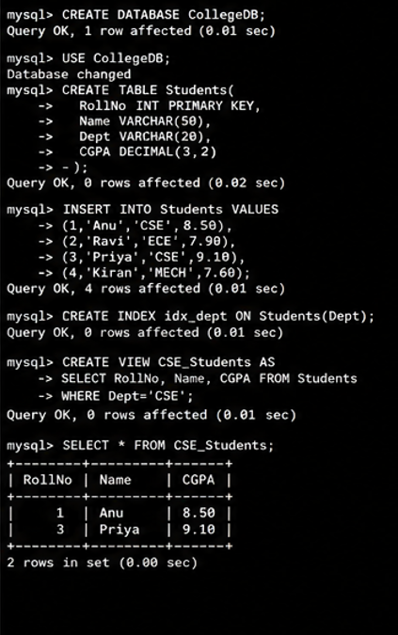
RESULT:
The records from the tables are displayed using view and index on the given relation.

